

SCHOOL TRANSPORT ASSISTANCE: APPLICATION FORM

Please read the information on this page before completing this application form

- A school students may be eligible for School Transport Assistance if:

- They are a Year 1-8 student and live more than 3.2 km from the nearest school or
- They are a Year 9 student or over and live more than 4.8 km from the nearest school
- In either case, the student does not have access to suitable public transport to get them to and from school

- This application form is for ONE STUDENT ONLY. All other children must have their own individual form

- This application form is to be used to apply for:

- a Ministry funded school bus place
- a Conveyance Allowance or
- both

- This application form is made up of two sections:

Section A: to be completed by the Caregiver, and then forwarded to the student’s school

Section B: to be completed by the Principal or School Bus Controller and then forwarded to the Ministry’s
local Service Agent for processing

- Further details on the Ministry’s rules on eligibility are available at www.minedu.govt.nz/schooltransport

PRIVACY ACT 1993 STATEMENT

- The information entered on this form will be used by the Ministry of Education for statistical information and the purpose of funding school transport only

Checklist for Caregivers

Student’s Year Level is entered 
Caregiver’s postal details included 
Caregiver has signed and dated form 
Date assistance is required from 
A printed or bank certified deposit slip 
or statement is attached (only if applying
for a Conveyance Allowance)

Section A: To be completed by the Caregiver

1. Student’s Details Please print clearly as this will assist with the processing of your application

Student’s First name
Student’s Family name
School Attending | Pukekohe High School
Address | House Number or name |  |  |  |  |  | Emergency Services RAPID Number
Street/Road name
Suburb
City/Town |  |  |  |  |  | Postcode
Student’s date of birth | / / |  |  | Year Level
Gender | Male |  |  |  |  |  |  | Female |  |  | 
Student Ethnicity | NZ European |  |  |  |  |  |  | Pacific Island |  |  | 
This information is collected for statistical purposes only | Maori |  |  |  |  |  |  | Asian |  |  | 
This information is collected for statistical purposes only | Other |  |  |  |  |  |  | Please specify:
Distances one way from
Home to school bus stop |  |  |  |  |  |  |  |  | km
Home to public transport stop |  |  |  |  |  |  |  |  | km
Home to nearest school |  |  |  |  |  |  |  |  | km
Home to school attended |  |  |  |  |  |  |  |  | km
Nearest school
School previously attended
PLEASE NOTE: If the student travels the full distance from home to school by private vehicle, or travels more than 2.4 km to the school bus stop, their caregiver may be eligible for a Conveyance Allowance.
I think I am eligible for the Conveyance Allowance Yes  No 
If you think you are eligible for a Conveyance Allowance, you will need to attach a verified bank generated deposit slip or statement for the account you would like the money to be deposited into.
The attached deposit slip is for: The caregiver’s account  or another account 

If the account is not the caregiver’s please provide the name of the account: ________________________________
Completion of this section is a legal requirement before any payments can be made. If this application is declined any bank account information which has been provided will be destroyed.

Attach Deposit Slip here: (only if applying for a Conveyance Allowance)
Example
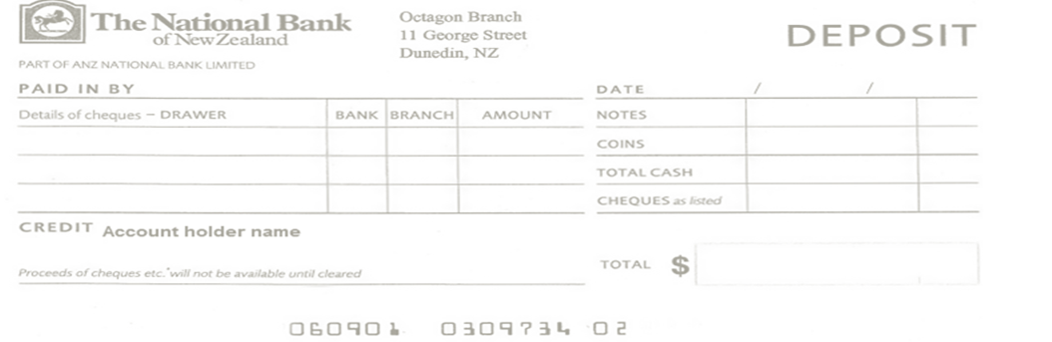

2. Caregiver’s Details Please print clearly as this will assist with the processing of your application

Caregiver’s First name
Caregiver’s Family name
Home Address |  | House Number or Name |  |  |  | Emergency Services Rapid Number (if known)
Street/Road name
City/Town |  |  |  |  |  |  | Postcode
Day contact phone numbers |  |  |  |  | Email Address
Date student enrolled in present school |  |  |  |  | / /
Date assistance for student required from |  |  |  |  | / / |  |  | Note: Conveyance Allowance payments will only be backdated to beginning of term prior to term the application was received by the Service Agent
Are there other students in your household applying for or already receiving School Transport Assistance?
No  Yes  If yes, please fill out the details for other students
Student Name |  |  |  | School Attending
Student Name |  |  |  | School Attending
Student Name |  |  |  | School Attending
Student Name |  |  |  | School Attending
3. Declaration: I declare that the information entered on this form is true and correct. I undertake to notify the school and the Service Agent of any changes to the information entered on this form.

Signature: |  |  |  |  |  |  |  |  | Date: / /
Caregiver’s Signature
Section B: School Information – to be completed by the school



4. School Details Please print clearly as this will assist with the processing of the application.

School Name |  |  | Pukekohe High School
School Institution Number |  |  | 103
5. Suggested Student Transport The suggested transport for this student is:
Conveyance Allowance |  |  |  | School Bus | 
If Bus: | Route Number: |  |  | Route Name:
 | Route Number: |  |  | Route Name:

6. Declaration of Enrolment

I declare that: | Student name:
Is enrolled at: | School name:
I declare that the information entered on this form is true and correct. I undertake to notify the Service Agent of any changes to the information entered on this form, or of changes in a student’s eligibility for School Transport Assistance.

Signature: |  | Date: / /
Principal/Bus Controller’s Signature

Checklist for Principal/Bus Controller
School name and School institution number entered 
Principal/Bus Controller has signed and dated the form 
All required Caregiver’s sections in Section A are filled in 



North Island only: Multiserve South Island only: School Support Ltd
Private Bag 92617 PO Box 115
Symonds Street Twizel 7944
Auckland 1150

